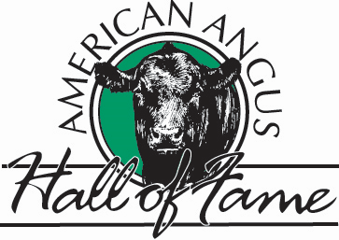

**Tom Burke Kurt Schaff Alex Popplewell**

- Sale Managers -

## WORLD ANGUS HEADQUARTERS

Box 660, Smithville, Missouri 64089-0660

Phone: 816/532-0811 [www.angushall.com](http://www.angushall.com)

Email: [angushall@angushall.com](mailto:angushall@angushall.com)

: 816/532-0811 FAX: 816/532-0851

[angushall@angushall.com](mailto:angushall@angushall.com) [www.angushall.com](http://www.angushall.com)

August 28, 2024

Dear Friends,

Attention all Angus enthusiasts and breeders! The American Angus Hall of Fame invites you to participate in the Second Annual National Angus Heifer Calf & Bull Sale. This event will be held at the Kentucky State Fairgrounds in Louisville, Kentucky, as part of the North American International Livestock Exposition. The sale will take place in the New Market Hall Sale Pavilion on Sunday afternoon, November 17th, at 3:30 PM EST. For your convenience, the sale will be broadcast live online at LiveAuctions.tv for internet bidding.

We will be accepting the following:

• Spring-born heifer calves

• Fall yearling open heifers

• Spring-bred heifers

• Exceptional cow/calf pairs

• Bulls

• Significant embryo packages & semen lots

(ALL LIVE ANIMAL LOTS MUST BE HALTER BROKE, NO loose consignments.)

If you are interested in becoming a consignor for this prestigious Angus event, please contact the Sale Chairman, Alex Popplewell with any questions or concerns at 270-566-8822 or by email at [alex@angushall.com](mailto:alex@angushall.com). We can send you a nomination/entry form by mail or you can submit it via email. We are looking for the best of the best to ensure the success of this National sale. Please don't hesitate to reach out to us at any time. We are excited to work with you and assist in marketing your consignments. In late September, we will be planning a tour to view all consignments for the sale. At the American Angus Hall of Fame, we are here to serve you. Thank you for considering this opportunity!

Best Regards & God bless,

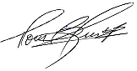 Schaff, Kurt_sig          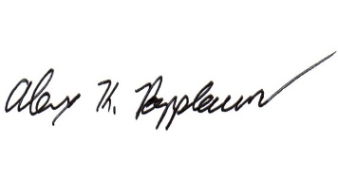

Tom Burke                 Kurt Schaff            Alex Popplewell

(816) 853-2697         (816) 520-6447       (270) 566-8822

*-Angus Sales Only Since 1939 / Now in our 85th Year-*